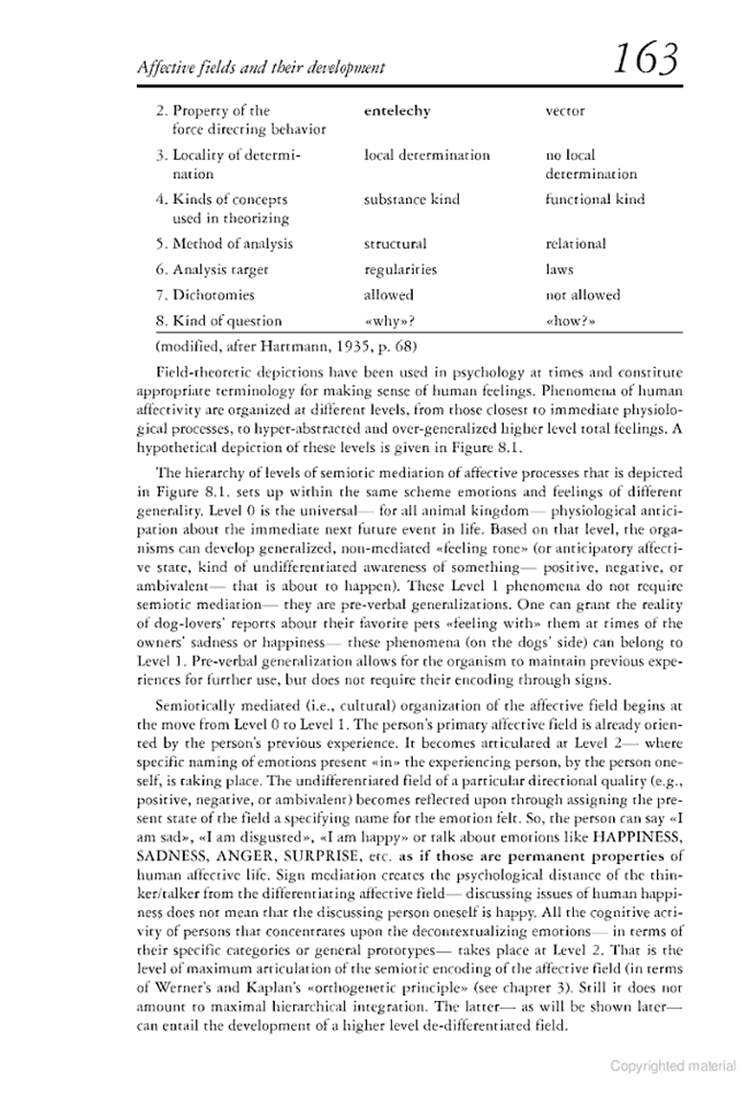
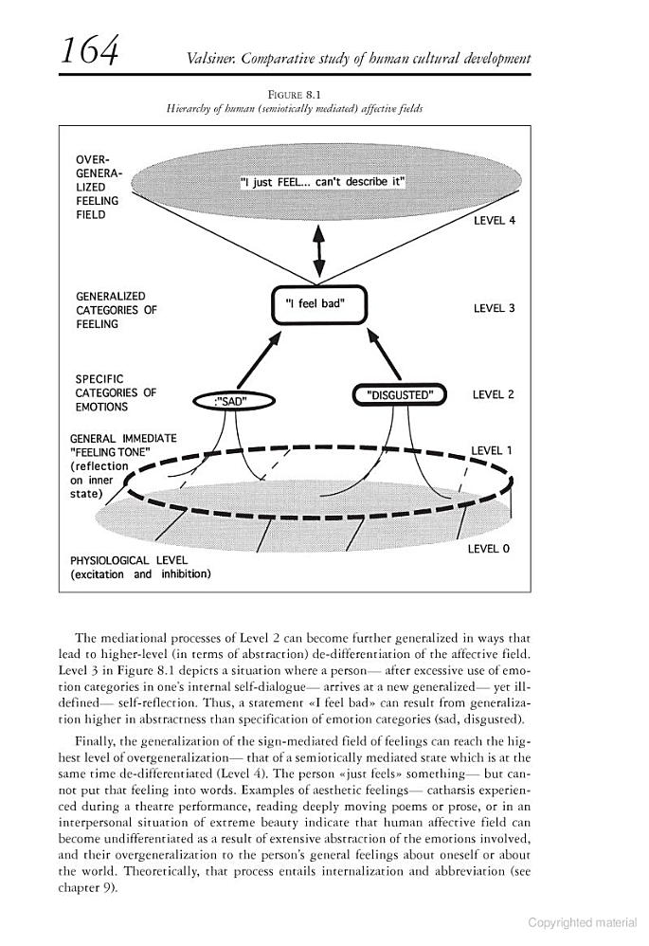

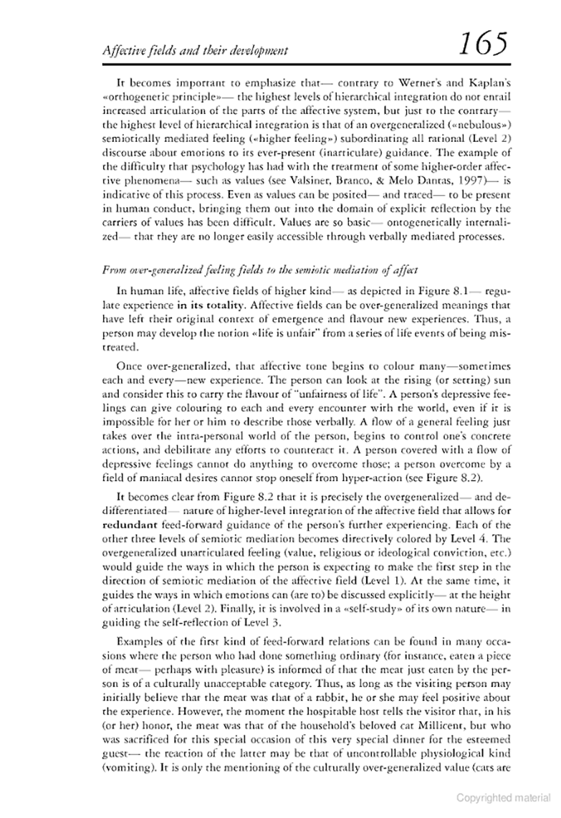

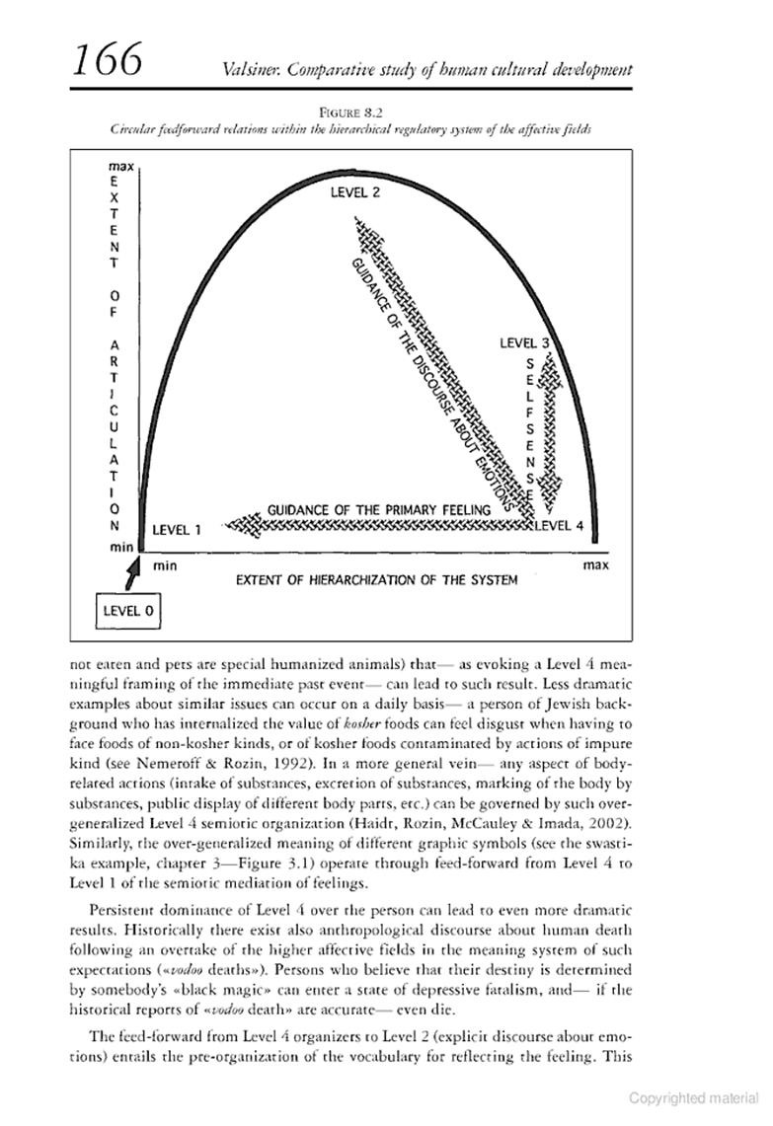

167 and 168 not previewed

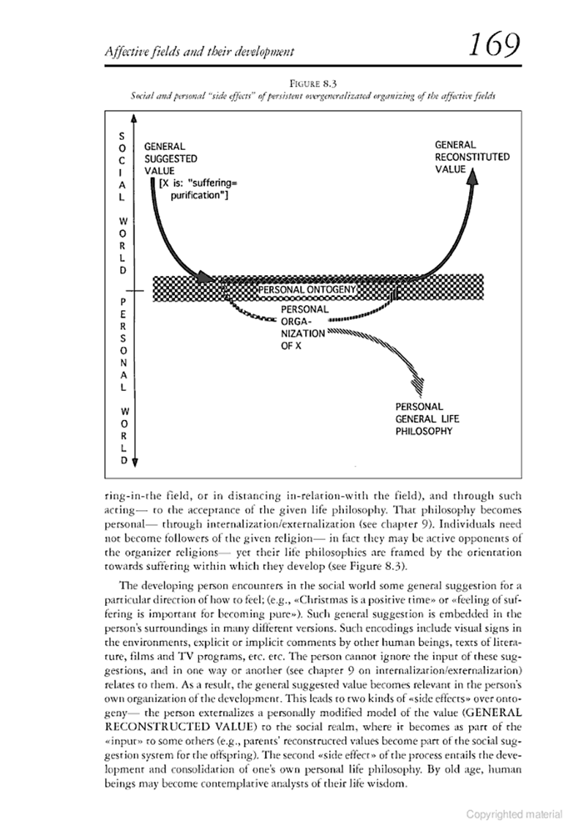

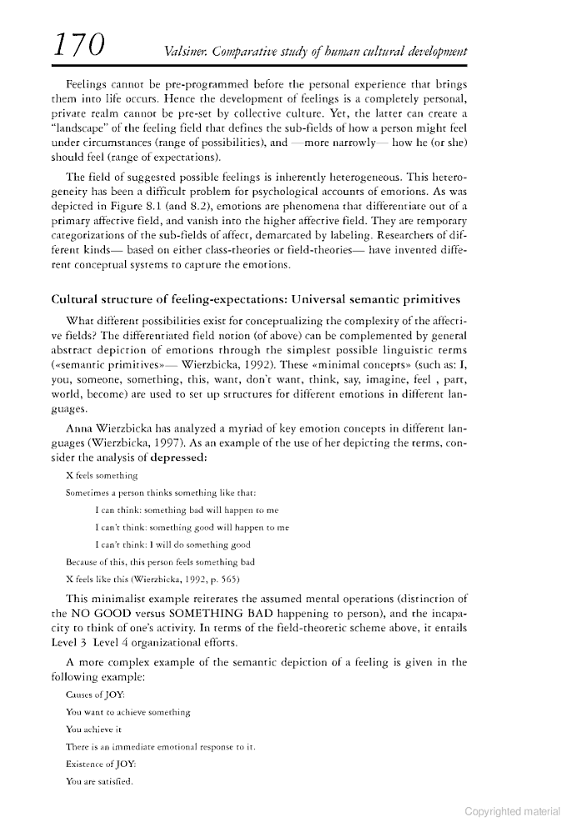
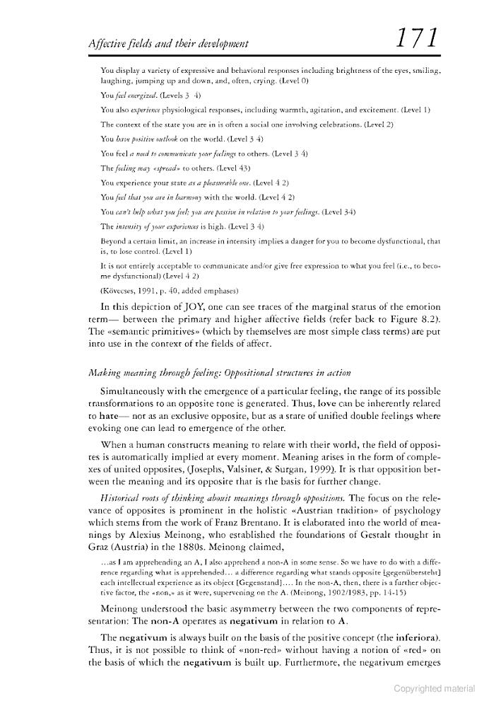
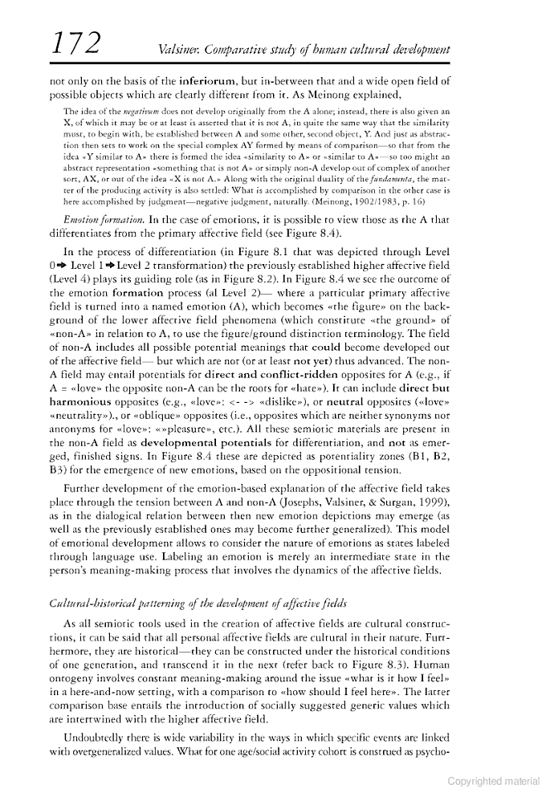

Web Images Videos Maps News Shopping Gmail more ▼
Books Finance Translate Scholar Blogs
YouTube Calendar Photos Documents Reader Sites Groups
even more »
My library | Sign in
Advanced Book Search
Comparative study of human cultural development
By Jaan Valsiner

Inserted from <http://books.google.com/books?id=iYgp55xAQwEC&pg=PA165&dq=valsiner+level+4+in+semiotic+mediation&hl=en&ei=UjxlTPrzPMGAlAfOwNySDg&sa=X&oi=book_result&ct=result&resnum=1&ved=0CC8Q6AEwAA#v=onepage&q=valsiner%20level%204%20in%20semiotic%20mediation&f=false>

